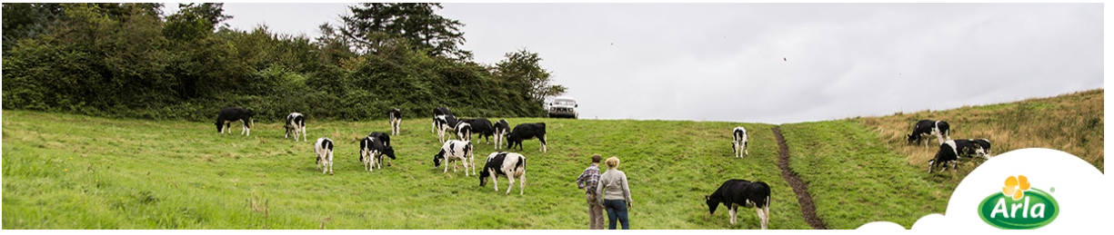

Sensory Scientist

Sensory & Consumer Science team, Arla Innovation Centre, Aarhus
Are you ready to join the highly ambitious Design & Connect team in Arla’s Global Innovation Centre in Skejby?
Here you will take part in creating the future of Arla Foods - making the great taste of our dairy products even better, and delighting consumers!

About the job
At the Innovation Centre, you will join the Sensory & Consumer Science team, a team of 12 sensory and consumer scientists and technicians (DK, SE, UK and BH). We are part of Design and Connect where product designers create the future pipelines of products. You will be key in delivering sensory insights and recommendations to both innovation and business. Doing so, you will work closely with product designers and consumer scientists on the product experience, and scientists and stakeholders across the organisation. As sensory scientist, you will drive the strategic development of our sensory competences, identify new methods, leverage science internally and externally, build our external collaboration with universities together with our sensory scientists. To help you create results we have trained sensory panels, panel leaders and access to consumer panels as well.

Drive our sensory competence development
- Take lead in the strategic development of sensory competence within product experience
- Drive internal research and inspire, embed and implement external research
- Build and maintain a network, with universities, organisations and suppliers
- Amaze and engage the Arla Innovation community in sensory perception from prototyping to launch
- Manage and further develop guidelines for best practise in our sensory panels

Design and manage sensory studies to support business
- Work with stakeholders to identify research needs, derive briefs and add to insight generation
- Design experiments and test series
- Select and use suitable research methods
- Analyse and synthesize test results into insights to communicate to stakeholders

Methodology and competences
- You have strong knowledge of sensory science, methodologies, multidisciplinary approaches and are passionate about it.
- Solid skills in basic and advanced data analysis, statistics and modelling. Advanced user of software for sensory data collection (Compusense, Qualtrics or similar) and statistical analysis (XLSTAT, SPSS, R or similar).

Your profile

We are looking for a new colleague with a strong interest in applied sensory science, with at least 3 years of experience working with sensory science (trained panels) within the FMCG industry. You have a relevant university degree, preferably a PhD with sensory specialization and used to communicate professionally in English. Further:
- You are eager to use your insights within sensory science in a business environment, and have strong communication skills to share these insights.
- You are a team player who involves, shares and engages your fellow scientists.
- You are inspired by uncovering sensory insights within consumer experience and you are curious, analytical and strategic in your approach.
- You have the experience that allows you to comfortably interact with a wide variety of stakeholders, both externally and internally, and manage multiple projects.

What we offer
In the Sensory & Consumer Science team, you will work alongside skilled colleagues who are dedicated to combining consumer and sensory research to optimize the user experience of our products.
We’re committed to professional development and promoting from within. Our positive and collaborative culture will bring out the best in you. And you’ll join a market leader who produces nutritious household-favourite brands in a way that makes things better for our consumers, our farmer-owners, and society.

Application and contact
If you want to drive sensory science excellence in a global dairy company, then seize this exciting opportunity. For additional information, please call Head of Department, Lisbet Bjerre Knudsen on +45 8938 1388.

We have a purpose for Good
At Arla, we strive to unlock the highest potential in each other while working together to create a sustainable future of dairy. We call it Stronger People Stronger Planet and it is deeply anchored in our organisation and founded on our commitment to respecting human rights, increasing access to healthy dairy nutrition, inspiring good food habits, and improving the environment for future generations. In order to succeed we need to hire people with a sustainable mindset. Could this be you?

#LI-DOJEB Ref.: 81315

